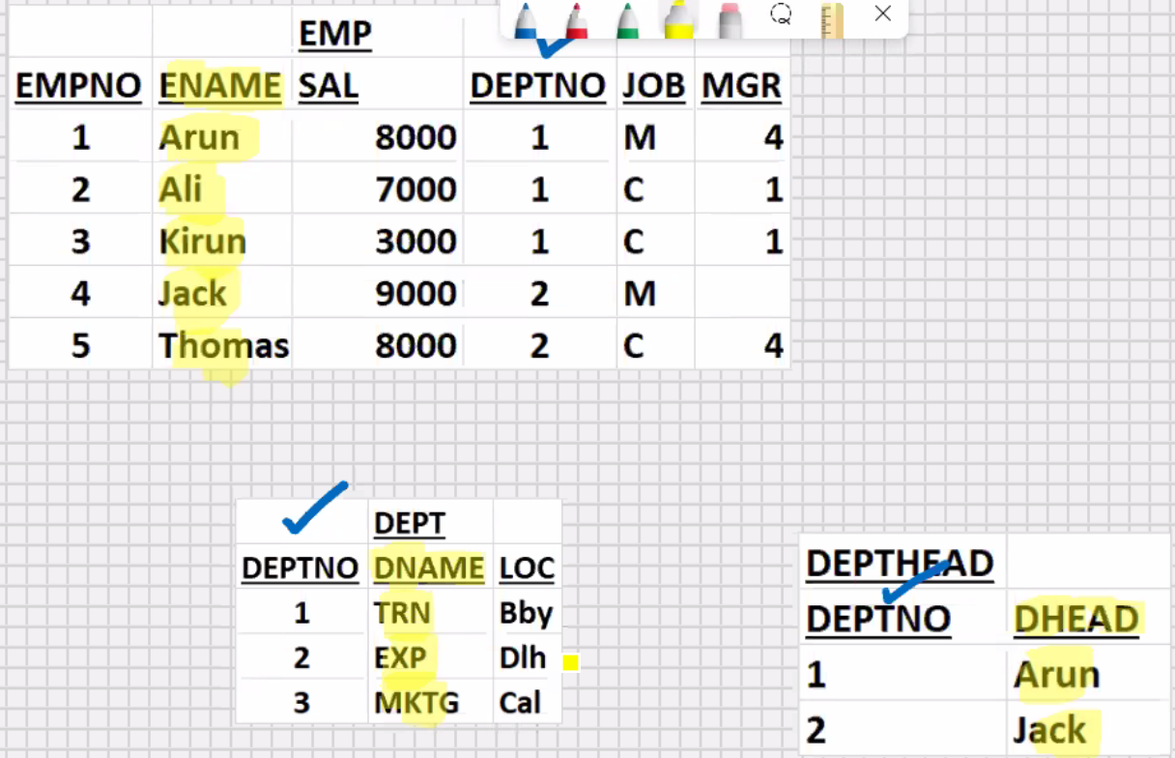

<<----- <<-----

Select dname, ename, dhead from emp, dept, depthead

Where depthead.deptno=dept.deptno

And dept.deptno=emp.deptno;

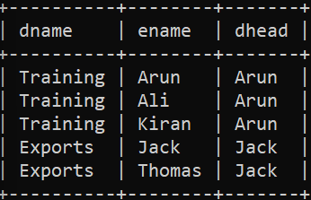

**Types of Relationships**

1 : 1 (dept : depthead) or (depthead : dept)

1 : many (dept : emp ) and (Depthead : emp)

Many : 1 (emp : dept ) and (emp : depthead)

Many : Many (projects : emp) or (emp : projects)

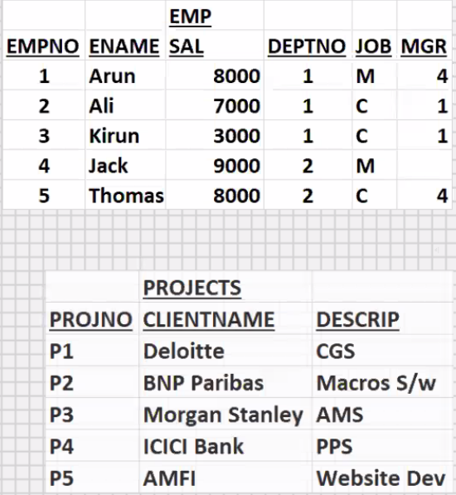

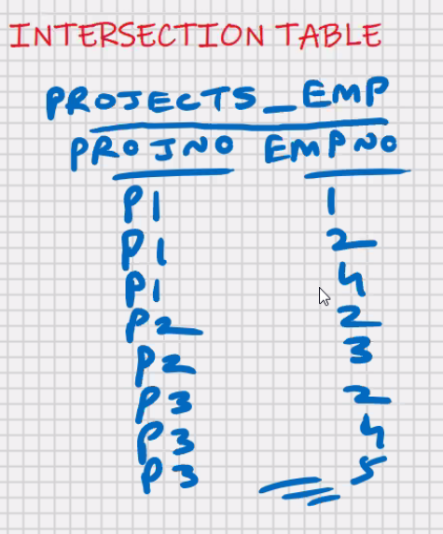**Intersection table**

* Intersection table is required

For Many : Many Relationship

Select clientname, ename,descript

From projects_emp, emp , projects

Where projects.projno = projects_emp.projno

And emp.empno = projects_emp.empno

Order by 1, 2, 3;

**MySQL – SQL – Sub-queries**

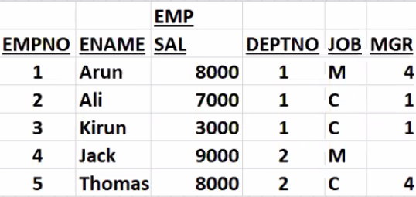

* Query within query (select within select) (Nested Queries)

**Display the ename who is receiving sal = min(sal):**

Select ename from emp //main query (outer query) (parent)

Where sal =

(select min(sal) from emp) ; //sub-query(inner query) (child)

ENAME

----------

Kirun

Select ename from emp //main query (outer query) (parent)

Where sal =

(select min(sal) from emp

Where deptno =

(select deptno from ………….

Where job =

(select …………………)

)

) ;

* Max upto 255 levels for subqueries (this limit of SQL can be exceeded with the help of views)

Select ename from emp

Where sal =

(select min(sal) from emp

Where deptno = 1) ;

* Join is faster than sub query(when you solve a problem using join, you solve the problem using one select statement; when you solve a problem using subquery, you require two or more select statements)
* The more the number of select statements, the slower it will be

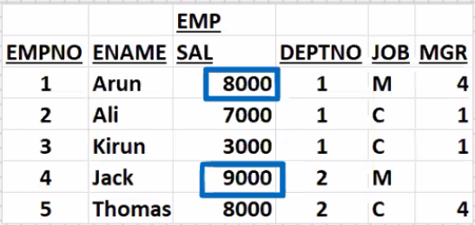Display the 2nd largest SAL:

Select max(sal) from emp

Where sal <

(select max (sal) from emp);

Display all the rows who belong to the same deptno as ‘Thomas’:

Select * from emp

Where deptno =

(select deptno from emp

Where ename = ‘Thomas’);

Display all the rows who are doing the same job as ‘Kirun’:

Select * from emp

Where job =

(select job from emp

Where ename = ‘Kirun’);

Using sub-queries with DML commands

Delete from emp

Where deptno =

(select deptno from emp

Where ename = ‘Thomas’);

Update emp set sal = 10000

Where job =

(select job from emp

Where ename = ‘Kirun’);

* Above 2 commands will work in oracle
* Above 2 commands are not supported by MySQL

**Using sub-queries with DML commands:-**

* In MySQL you cannot update or delete from a table from which you are currently selecting

**Solution for MySQL**:

Delete form emp

Where deptno=

(select tempp.deptno from

(select deptno from emp

Where ename = ‘Thomas’)as tempp);

Update emp set sal =10000

Where job =

(select temp.job from emp

(select job from emp

Where ename = ‘Kirun’)as temp);

**Multi-row Sub-queries (Sub-query returns multiple rows)**

Select * from emp

Where sal = any (8000,9000)

(select sal from emp

Where job = ‘M’);

Select * from emp

Where sal in (8000,9000)

(select sal from emp

Where job = ‘M’);

* Any operator is overloaded that’s why in operator is faster
* But any operator is powerful

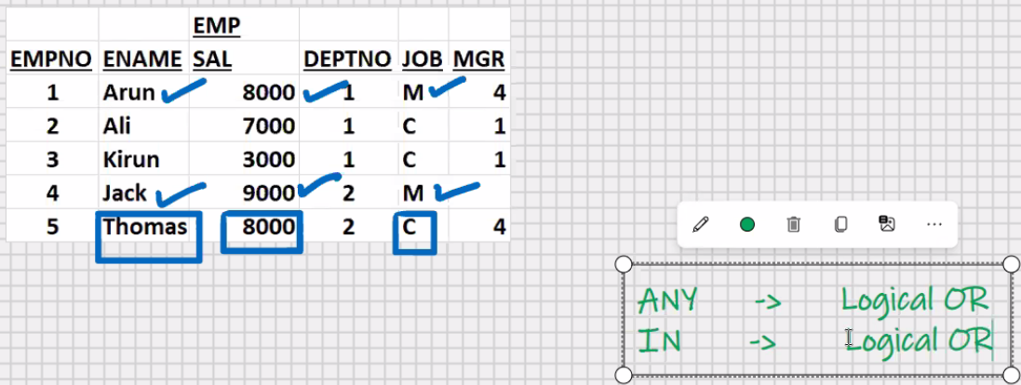

Select * from emp

Where sal >= (8000)

(select min(sal) from emp

Where job = ‘M’);

**To make it work faster:-**

1. Join is faster than sub-query

**Try to solve the problem using join**

1. Tyr to reduce the number of levels of sub-queries
2. Try to reduce the number of rows returned by sub-query

**\*Assumption 3rd row sal is 13000**

Select * from emp

Where sal > all (8000,9000)

(select sal from emp

Where job = ‘M’);

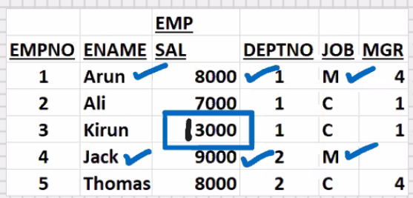

**All** is a special operator performs **logical And**

Select * from emp

Where sal > (9000)

(select max(sal) from emp

Where job = ‘M’);

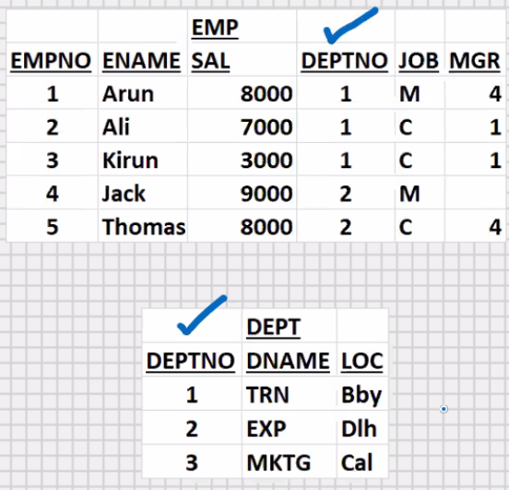**\* Assumption 3rd row sal is 3000**

Using sub-query in the having clause:-

In Oracle : -

Display the dname that is having

Max(sum(sal))

Select deptno, sum(sal) from emp

Group by deptno;

Deptno sum(sal)

---------- -----------

1 18000

2 17000

Select sum(sal) from emp

Group by deptno;

Sum(sal)

------------

18000

17000

Select max(sum(sal)) from emp

Group by deptno;

Max(sum(sal))

-------------------

18000

Select deptno, sum(sal) from emp

Group by deptno

Having sum(sal) =

(select max(sum(sal)) from emp

Group by deptno);

Deptno sum(sal)

---------- -----------

1. 18000

Select dname, sum(sal) from emp, dept

Where dept.deptno = emp.deptno

Group by dname

Having sum(sal) =

(select max(sum(sal)) from emp

Group by deptno);

Dname sum(sal)

--------- -----------

TRN 18000

In MySQL:-

Select sum(sal) from emp

Group by deptno;

Sum(sal)

-----------

18000

17000

Select max(sum_sal) from emp

(select sum(sal) sum_sal from emp

Group by deptno ) as tempp;

Max(sam_sal)

------------------

18000

Select deptno, sum(sal) from emp

Group by deptno

Having sum(sal) =

(select max(sum_sal) from

(select sum(sal) sum_sal from emp

Group by deptno ) as tempp);

Deptno sum(sal)

---------- ------------

1. 18000

Select dname, sum(sal) from emp, dept

Where dept.deptno = emp.deptno

Group by dname

Having sum(sal) =

(select max(sum_sal) from

(select sum(sal) sum_sal from emp

Group by deptno) as tempp);

Dname sum(sal)

---------- ------------

TRN 18000